42.22: 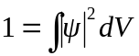
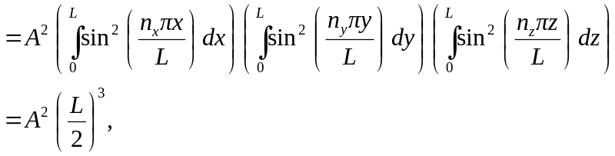
so 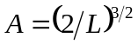 (assuming A to be real positive).

